ACOs’ Use of Telehealth During the COVID-19 Pandemic

May 25, 2021

The COVID-pandemic exposed many of the flaws in the US health care system including disparities in access to care, fragmentation of services, inadequate investment in public health and a financing model dependent on service volume. In addition to the human toll, the pandemic has strained the healthcare system’s finances as elective procedures were canceled, medical offices closed, and patients avoided care for fear of infection. Health care organizations made operational changes at an unprecedented pace to create safe ways for their patients to access care, and to support providers – particularly small independent practices – to help them continue operating and remain financially viable. Many changes that occurred in 2020 were facilitated by emergency payment waivers enacted by Centers for Medicare and Medicaid Services (CMS) in response to the public health emergency. These waivers allowed providers to be reimbursed for new modes of care in non-traditional settings including patients’ homes.
The new regulatory flexibilities and payment waivers created opportunities for health care organizations to deliver care more efficiently, effectively and conveniently. Accountable Care Organizations (ACOs) are well positioned to take advantage of the new flexibilities to improve care. ACOs have already adopted the philosophy and practices of population health and participate in contracts with financial incentives to manage spending and improve outcomes. Most ACOs have invested substantial resources in population health analytics, care coordination and engagement of patients outside of traditional medical settings. These resources combined with the relationships they have developed with high-risk patients may have helped them serve vulnerable patients more effectively during the pandemic. Most ACOs want to continue using the new practices they developed during the pandemic as the health care system returns to its new normal.
To understand how ACOs have responded to the pandemic we conducted structured interviews with senior executives from seven diverse ACOs in November and December 2020. We interviewed two leading experts in medical coding and billing to understand how new waiver services – particularly telehealth – were billed, and how to identify those services in claims data. We analyzed 2020 monthly Medicare claims data for 28 million Medicare beneficiaries to examine trends in service utilization for both ACO-attributed and non-ACO beneficiaries
Accountable Care Organizations
ACOs are networks of providers that engage in contracts where they are responsible for managing a defined group of attributed beneficiaries with payment tied to an overall spending target. ACOs share in savings if spending for their beneficiaries is less than the annual target as long as they meet the contract’s quality performance standards. In Medicare, the budget includes all Part A (facility) and Part B (professional) services but does not include Part D (prescription drugs). ACOs are extremely diverse. Some are organized around large integrated delivery systems while others are formed around community hospitals or independent medical groups. In some organizations only certain providers participate in ACO contracts while in others the provider group is synonymous with the ACO. Some groups participate in a single ACO contract whereas others have such contracts with multiple payers. The ACO executives we interviewed were focused on the full complement of providers and patients in their organizations regardless of whether or not they participated in the ACO. Below, we summarize our findings from the executive interviews and our analysis of utilization trends during the pandemic.
ACO and Health System Responses to the Pandemic
ACO executives had two main priorities at the beginning of the pandemic: maximizing patient and staff safety; and maintaining financial solvency. Safety required ensuring providers had sufficient personal protective equipment (PPE), staff training in infection control protocols, and operating procedures to limit the spread of COVID-19. Financial solvency required rapidly establishing the capability to conduct virtual visits so providers could continue to see patients and bill for services.
Before the pandemic, some commercial payers covered select telehealth services albeit at relatively low payment rates. Medicare coverage of telehealth was primarily limited to rural areas and required patients to come to an “originating site” like a hospital or physician office for a virtual visit. Only one of the seven ACOs we interviewed used telehealth prior to the pandemic, accounting for 2% to 4% of its total patient visits. As soon as CMS expanded its coverage for telehealth services, most US provider groups began urgently preparing to conduct virtual visits.
Health systems began a rapid push to evaluate telehealth solutions and select one to deploy for their clinicians. Many larger systems already had access to a telehealth platform through their electronic medical record (EMR); this was typically the solution these groups selected for their employed physicians. Equipping independent physicians was more challenging because many have small staffs, limited resources and disparate EMR systems. ACO teams were deployed to help independent practices set up and operate telehealth technology and to educate providers about Medicare billing and coding regulations, which were updated frequently. Very important for the initial deployment of virtual visits were CMS waivers allowing the use of non-HIPPA compliant platforms like Facetime and Zoom while providers were assessing more robust platforms.
Nationally, telehealth service use peaked in April 2020. Our interview respondents reported telehealth rates of 40% - 50% of total visits during that period across all payers, with one executive reporting an 80% telehealth visit rate at the peak of the pandemic. Recent research concluded that telehealth made up about 30 percent of all ambulatory visits from March 18 – June 16, 2020. Telehealth visit rates were higher for patients under 60 years old (30 – 39% depending on age cohort) and were 23.7% for patients aged 65 or older.
We conducted our own analysis of Medicare telehealth utilization through November 2021. Exhibit 1 shows total Medicare ambulatory visits including telehealth visits along with the percentage of total visits with telehealth. We found that Medicare telehealth visits were about 23% of total visits in April 2020 and then declined steadily to about 8% of total visits by November 2020.
Exhibit 1
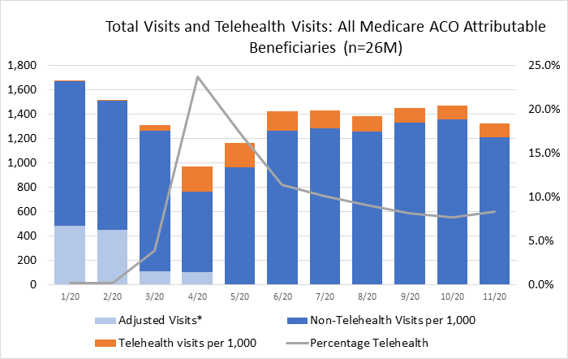
Source: IAC analysis of monthly claims data. Analysis reflects all services eligible for telehealth. Adjusted visits reflect visits not eligible for telehealth billing in that month so that total visit rate is consistent across all months.

Medicare telehealth utilization peaked at about 200 monthly visits per 1,000 beneficiaries in April 2020 and then declined to just above 100 monthly visits per beneficiary by November (Exhibit 2). Telehealth visit rates were twice as high for high-need, high-cost beneficiaries which we defined as individuals with a diagnosis of Alzheimer’s, Atrial Fibrillation, COPD, heart failure or chronic kidney disease, and a prior hospitalization, SNF stay of at least 14 days, or three ED visits in 2019. Although ACOs may have provided operational support for providers to implement telehealth, we found that average telehealth visit rates were nearly identical for Medicare ACO and non-ACO beneficiaries. There was, however, substantial variation in rates across ACOs ranging from fewer than 50 telehealth visits per 1,000 Medicare beneficiaries to more than 600 visits per 1,000 in April 2020 (Exhibit 3).

Exhibit 2
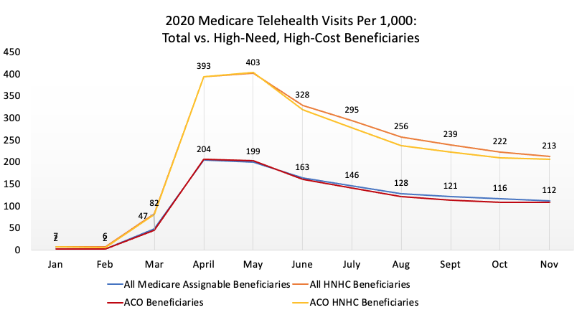

Exhibit 3
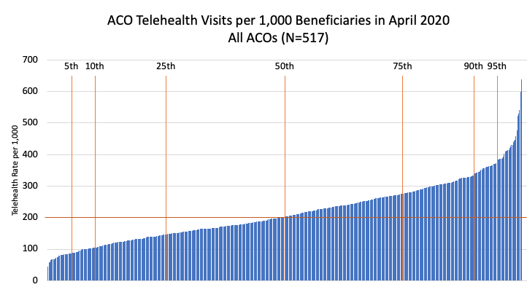

In addition to telehealth, ACOs are also investing in remote patient monitoring (RPM). At the end of 2019, CMS added several new billing codes for RPM and allowed these services to be “incident to” the general supervision of a qualified health professional – expanding the opportunity to bill for RPM services when the supervising professional and the monitoring staff are not in the same location. Two ACO respondents – both embedded in large health systems had piloted remote monitoring of high-risk patients prior to the pandemic and both organizations were in the process of expanding their RPM efforts. One of these ACOs planned an expansion of RPM services to several thousand chronically ill patients with clinical pharmacists as the supervising professionals. Other ACO respondents expressed interest in RPM but had not yet implemented it.
ACO Activities During the Pandemic
Traditional health care organizations operate with an “inbound” focus – meaning that they wait for patients to come to them when they are sick or injured. In contrast, ACOs are more population health-focused and interact with patients – particularly those with medical and social complexity – outside of scheduled medical visits. ACOs have a formal care management structure with personnel dedicated to working with complex patients on an ongoing basis to maintain health and to intervene quickly when flare-ups of chronic conditions occur. Several ACO respondents told us that a major priority during the pandemic was to help their entire system “shift us from an ‘inbound’ to an ‘outbound’ orientation.”
Virtually all ACO respondents reported re-tasking population health teams to focus on patients at high risk for adverse outcomes if they contract COVID-19. ACOs use a variety of risk identification and stratification tools to prioritize outreach by their care management teams. ACOs modified these analytics to focus on patients with risk factors related to COVID-19. Care teams then began with outbound calls to vulnerable patients to identify needs, provide advice and direct resources as necessary. ACOs took steps to help beneficiaries affected by social determinants of health like food insecurity. This included coordinating with community service agencies and in some cases having staff deliver food boxes or medications.
In 2020, CMS ruled that Medicare ACOs with downside risk would not be required to pay back financial losses if they incur excess spending during the public health emergency. ACOs were also concerned that if patients delayed care for fear of infection, their ACOs would lose large numbers of attributed beneficiaries, and those remaining in the ACO would be older and sicker. CMS also ruled that Medicare beneficiaries could be attributed to ACOs through telehealth visits. Because of this, a top priority of ACOs was reaching out to beneficiaries they hadn’t seen through the year and offering virtual annual wellness visits (AWVs).
Although health care providers had access to a range of waivers, the ACOs we spoke with primarily focused on telehealth. Health systems with hospitals pushed to capacity by COVID-19 patients took advantage of waivers allowing care in alternative sites, but that was generally not the focus of ACOs. Another waiver stakeholders mentioned using was the ability relaxed criteria allowing nurse practitioners and physician assistants to write home health orders.
Virtual Care Challenges
In 2020, virtual care provided a lifeline for patients and generated much-needed cash flow for financially struggling clinicians. Prior to 2020, the principal barrier to telehealth was reimbursement. But as telehealth became commonplace during the pandemic, other challenges emerged. A principal challenge was that virtual care requires a cultural shift for patients and physicians. While many patients are pleased to have access to telehealth, it is not universal. The rapid decline in telehealth as in-person visit volume started to rebound is evidence that telehealth has not yet achieved broad acceptance.
Physician support for telehealth has been mixed. One ACO executive told us “[telehealth] will probably be a sideline [in the long run] since most of our docs think that it’s inferior care.” Another executive noted the difficulties of launching telehealth saying, “How do you get the docs to understand how to do telehealth and build it into their workflow?” Another concern was that some patients had difficulty with the technology. A respondent told us that “in retrospect I would be much more aggressive putting technical support in place because many of our providers ended up as de facto tech support for their patients.” However, this individual also said that their system was “promoting [telehealth] as a significant part of our strategy going forward”.
There are also challenges from the patient side. Frail elderly patients often have difficulty with the technology unless they have a technologically adept caregiver. Some ACOs said most patients in their geographic market simply prefer going to see the doctor. Finally, several respondents noted the problem of unequal access to telehealth due to a “digital divide” in poor urban areas and rural communities where lack of broadband made virtual visits difficult or impossible.
Future Outlook for ACOs and Telehealth
Respondents interviewed for this study were generally positive about maintaining and expanding telehealth use in the future. But that is highly dependent on how CMS decides to pay for telehealth when the public health emergency ends.
One area where telehealth has great potential is home-based primary care. While providers are reimbursed for house calls, they spend significant unbillable time traveling from patient to patient. The resulting inefficiency could be ameliorated by integrating virtual care for some portion of visits. Lower-level staff could come to the patients’ home to set-up the visit, help with the exam using internet-enabled diagnostic equipment and follow up by picking up necessary medications or equipment. Virtual care would also be beneficial in SNFs by allowing for clinical visits during evening hours when most rehospitalizations occur. There is general agreement that CMS will continue payment for some telehealth services, but respondents were that skeptical CMS would keep payment rates at parity with in-person visits. One respondent told us that “we see opportunities to use telehealth to substantially change our operating model, but we aren’t going to do it if it isn’t reimbursed adequately.”
Respondents pointed to numerous opportunities for future innovation using telehealth. For example, several now conduct much of their non-urgent behavioral health services through telehealth. Managing care transitions is another opportunity. Most ACO care transitions programs reach out telephonically to patients discharged from hospitals and skilled nursing facilities (SNF) to ensure patients understand discharge instructions, are taking medications correctly and have a follow-up visit scheduled with their PCP within seven days. Virtual care transition visits would be more robust with the ability to examine wounds, observe the patients’ demeanor and home environment, and even conduct the patient’s follow-up primary care visit virtually.
The COVID-19 public health emergency and subsequent Medicare payment waivers led to a telehealth rollout of unprecedented speed – driven primarily by the “revenue emergency.” It is unlikely that CMS will put the telehealth genie completely back in the bottle. However, continued widespread use of telehealth and the broader system-level transition to virtual care will require thoughtful post-pandemic reimbursement policy, more research on the cost-effectiveness of different telehealth modalities and continued acculturation of US patients and physicians.

This paper was prepared by Robert Mechanic, Jennifer Perloff, Andrew Perlman and Sanjukta Pal with support from the West Health Institute

Sadiq Patel, Ateev Mehrotra et al. Variation in Telemedicine User and Outpatient Care during the COVID-19 Pandemic in the United States. Health Affairs. February 2021.

